Lesson 3 Student Activity Sheets: Are the population changes in buffalo related to changes in climate?
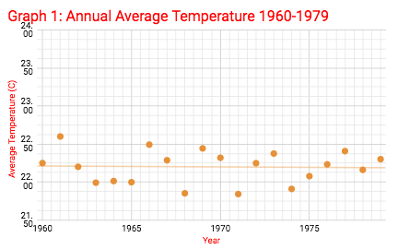
CLIMATE DATA:
5. What do you observe about the temperature graph?

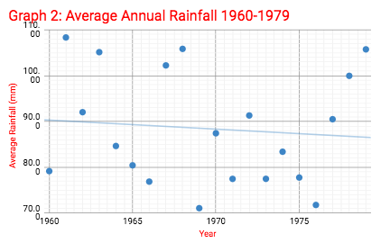

6. What do you observe about the precipitation graph?

7. What happened with the climate of Tanzania between 1960 and 1975?

CONCLUSIONS:
8. Do the trend lines of rainfall and temperature indicate that climate was the cause of the buffalo population increase? Explain.

SIMULATION: Using a computational model
You will use a computer simulation to explore what happen to a population of grazers in an ecosystem under different sets of environmental conditions.

INVESTIGATION 1: Population Size

In the screencast demonstration of the Netlogo computer model, you saw the initial population of 10 buffalo grow and then level off, around a stable population size between 35 and 45 buffalos (about 40 on average), once enough time passed (1500 to 2000 units of time).

9. What causes the population size to grow?

10. Why doesn’t the population size level off?

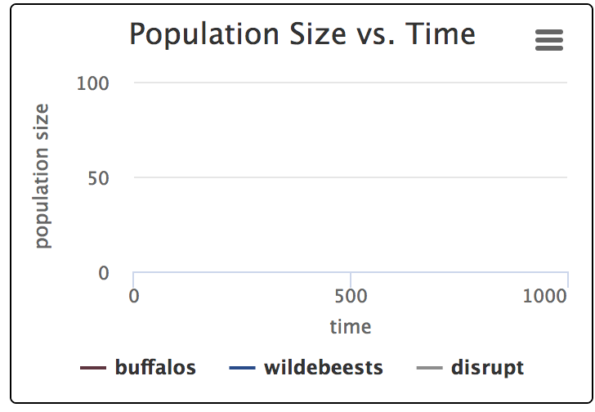
PREDICT:
11. If you started with 50 buffalo and ran the model for 1500 to 2000 units of time again, what do you predict the shape graph of population size vs time would look like?

Sketch your prediction in the graph to the right.

12. How do you think the size of the population will compare at the end of your model run, to what you see in the graph above?

PROCEDURE FOR INVESTIGATION 1:
- Open a web browser and go to this web address: http://serengeti.inquiry-hub.net/

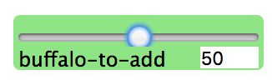
- Change the buffalo-to-add slider to 50.
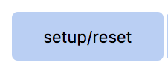

- Press the SETUP/RESET button. ------------>

- Press the GO/PAUSE button. ------------------>

- Keep the model running until the time is between 1500 to 2000. When you see this happen, press the GO/PAUSE button again to pause the model.

- Record the shape of the graph and the size of the population at this point in the space below.

- Repeat steps 4-6, changing the buffalo-to-add each time.

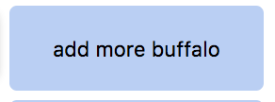
- Press the ADD-MORE-BUFFALO button as the model is running. Record any patterns you notice in the stability of the ecosystem in the space below.

Observations

MAKING SENSE:
13. Why did the population tend to return to a stable state of about 40 buffalo in many different situations?

14. Sometimes if you start with 100 or more buffalo, the entire population of buffalo will end up dying off. Why do you think this happens?

CONCLUSIONS:
15. How is the idea of carrying capacity related to the outcomes you observed in this model?

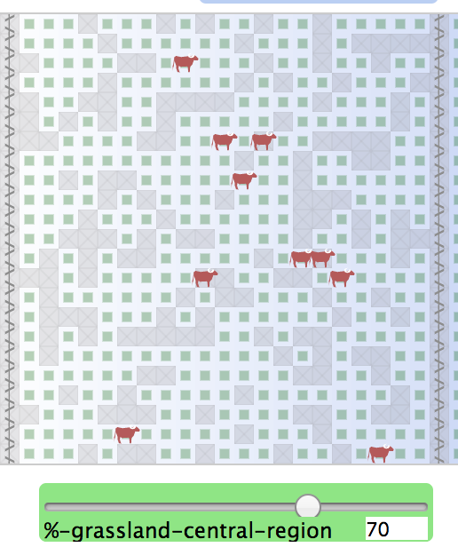
INVESTIGATION 2: Changes in Climate

PREDICT: In the next investigation you are going to change the ecosystem so that there is less space where grass is growing and a different amount of rain falling on those spaces.

16. If you started with 10 buffalo again, but reduced the amount of grassland to 70% of the space that growing grass in the previous investigation before how do you think that would affect the carrying capacity for buffalo in this ecosystem? An image of the model setup with this change is shown the right.

17. If you increase the rainfall across the region that the buffalo are in, how do you think that would affect the carrying capacity for buffalo in the ecosystem?

PROCEDURE FOR INVESTIGATION 2:

- Adjust the %-GRASSLAND-CENTRAL-REGION slider value to 80 (as shown above)

- Press the SETUP/RESET button. Then GO/PAUSE buttons.

- Keep the model running until the time is between 1500 and 2000. When you see this happen, press the GO/PAUSE button again to pause the model. Record the carrying capacity in the 1st column of the Results table in the BUFFALO monitor.

- Then change the SEASONAL-RAINS? And the BUFFALO-FENCES? settings as shown below for the 2nd experiment, and repeat the last three steps, recording the carrying capacity in the 2nd column below. Do this again for the 3rd column below, but turn the BUFFALO-FENCES off before pressing SETUP. Use the 4th column to record discoveries from any additional investigations you conduct. If you want to change a different variable than the ones listed, just add another row to the results table to indicate your variable.

Results Table
 | 1st | 2nd | 3rd | 4th
% grassland-central- region | 80 | 80 | 80 | 80
Buffalo fences? | yes | yes | no
Seasonal rain? | no | yes | yes
Number of buffalo

MAKING SENSE: - write responses to 18/19 in your journal.
18. Why did the changes you made to the environment in this investigation affect the carrying capacity of the ecosystem for the buffalo population?
19. What are you now wondering about? List some of your questions related to this case in your journal. At least 2.

