Exploring Roles Used in POGIL Groups

Why?

Many people respond negatively to working in groups, based on previous experiences as members of a poorly functioning and/or ill-planned group. The dynamics of the group can quickly become an obstacle to learning. In a process-oriented, guided-inquiry learning (POGIL) environment, the greatest overall learning occurs when each group is functioning well. To ensure effective functioning, you will take on a specific role and perform that role’s duties in addition to completing the day’s guided inquiry activity. You will change roles frequently (often every day), so that you become proficient at performing any role in any group setting. In this short activity, you will explore the duties of each role and will consider how these roles interact to create an effective and efficient group learning experience.

MODEL 1
Think about a team or group experience you had that did not go well. What were characteristics of the group that might have contributed to the group not functioning well.

Think about a group or team experience you enjoyed or felt was productive and worthwhile. What were some of the characteristics of the group that likely contributed to its success?

Share your thoughts with you group and be prepared to share with the class.
\
An Example of Roles used in POGIL Classrooms
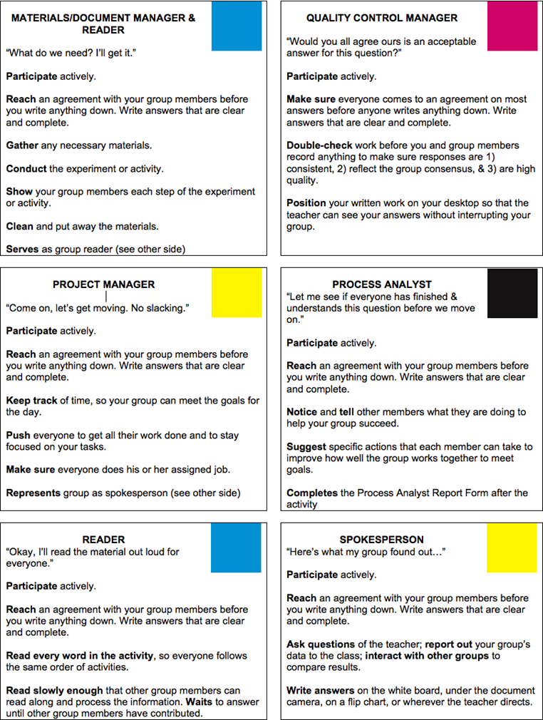
Make sure each member has a quality data table and data before end of class.
Data Manager

Before starting this activity, you will be assigned one or two roles. Circle your role(s) in the table (Model 1). Spend 2 minutes reading and becoming the expert ONLY on your assigned roles. You will perform all the tasks of your role(s) as you work with your group to complete the activity. You will also provide evidence from your role’s tasks to help answer the questions.

- Which role is responsible for keeping the group moving at a good pace?

- Which role is responsible for slowing the group down so everyone can reach an agreement and write down the same answer?

- List two responsibilities that every role has in common:

- Which role would be responsible for picking up handouts, lab equipment, or a calculator?

- Put a star in model 1 next to the only two people who will need to move around the room during class.

- Which two roles are most likely to come into conflict as they perform their duties? Explain your answer to question 6 in a complete sentence.

- Which role is responsible for watching how the group functions, and reporting on it once the activity is completed?

  - Do you think it is that person’s sole responsibility to complete that report, or should he/she solicit the input of the group? Explain your answer using complete sentences.

- If a group only has two or three members,

  - which role(s) would work best as primary roles (roles that cannot be performed by the same person)?

  - which roles might work best as secondary roles (roles that can be added to a primary role)?

- Describe 1 – 2 ways that using specific roles might help groups to function more effectively to help every group member learn.

- Just by yourself, list any questions you have regarding the use of roles in group work:

- Look over the process skills list and help the process analyst fill out their group work analysis form.

